  - Real-Time Scheduling Algorithms (EDF, RMS, RR, LLF)
Real-Time Operating Systems (RTOS) are designed to process data and events within strict time constraints. In embedded and real-time systems (such as medical devices, avionics, robotics, industrial controllers), tasks must be executed before their deadlines.
Scheduling algorithms determine which task runs at what time to ensure deadlines are met.

Real-Time Scheduling Overview
A scheduling algorithm decides the order in which tasks are executed by the CPU.
Typical parameters of real-time tasks:
- Execution Time (C) – CPU time required
- Period (T) – Time interval between task arrivals
- Deadline (D) – Time by which task must finish
- Priority – Importance of task
Type | Description
Hard Real-Time | Missing a deadline causes system failure
Firm Real-Time | Occasional misses allowed but not preferred
Soft Real-Time | Deadline misses degrade performance but system continues

Earliest Deadline First (EDF) Scheduling
Earliest Deadline First (EDF) is a dynamic priority scheduling algorithm used in real-time operating systems. It is designed to schedule tasks based on their deadlines, ensuring that tasks with the most urgent deadlines are executed first. EDF is widely used in systems where tasks must be completed within strict timing constraints.
EDF is considered an optimal scheduling algorithm for preemptive real-time systems because it can achieve maximum CPU utilization while still guaranteeing that all deadlines are met if the system is schedulable.

Principle
The fundamental principle of Earliest Deadline First scheduling is:
The task with the earliest deadline is assigned the highest priority and executed first.
Unlike fixed priority algorithms such as Rate Monotonic Scheduling, EDF assigns priorities dynamically. This means the priority of tasks can change during execution depending on their deadlines.

Characteristics of EDF
Earliest Deadline First scheduling has several important characteristics:
- Dynamic Priority Scheduling
Task priorities are not fixed. They change according to the deadlines of the tasks.
- Preemptive Scheduling
If a task with an earlier deadline arrives while another task is executing, the currently executing task is preempted.
- Optimal Scheduling Algorithm
EDF can schedule tasks successfully whenever a feasible schedule exists.
- Supports Periodic and Aperiodic Tasks
EDF can handle both periodic and non-periodic tasks efficiently.
Task | Execution Time (C) | Deadline (D)
T1 | 2 | 8
T2 | 1 | 5
T3 | 2 | 10
According to EDF scheduling:
- Task T2 has the earliest deadline (5), so it executes first.
- Next is T1 with deadline 8.
- Finally, T3 with deadline 10 executes.

CPU Utilization Condition
EDF scheduling guarantees that all deadlines are met if the following condition is satisfied:
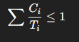
Where:
- Ci = Execution time of task i
- Ti = Period of task i
This means that the total CPU utilization must be less than or equal to 100%.
Unlike Rate Monotonic Scheduling, EDF can achieve full processor utilization.
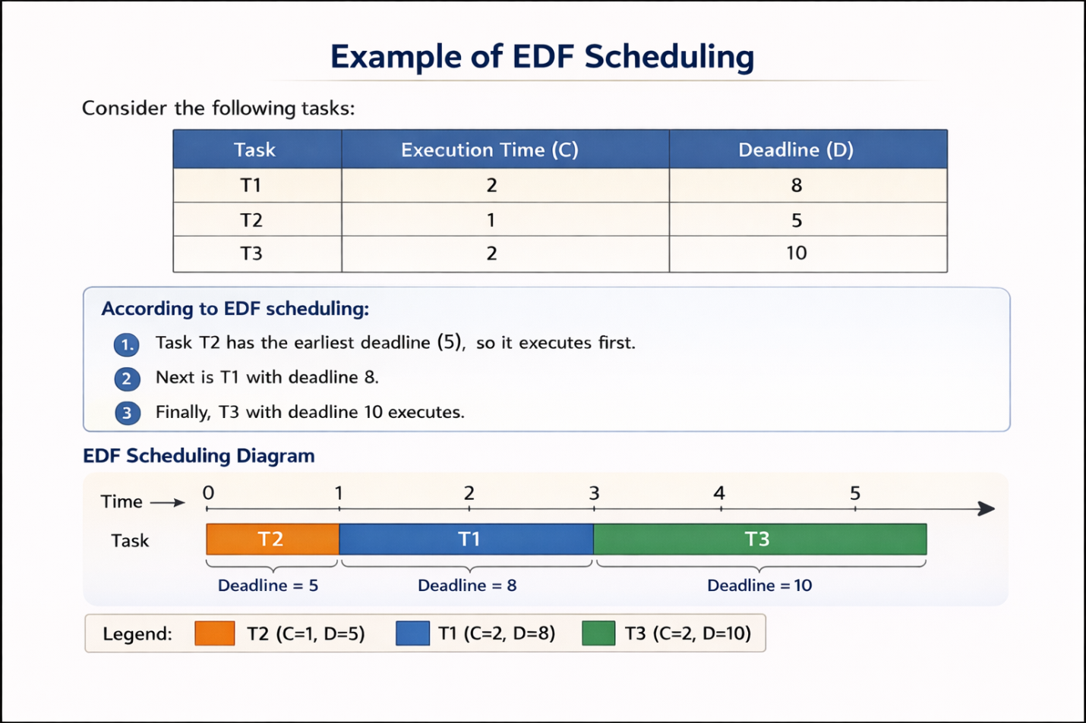

Advantages of EDF
Earliest Deadline First scheduling offers several advantages:
• Achieves maximum CPU utilization (100%)
• Optimal scheduling algorithm for preemptive systems
• Flexible and adaptable to dynamic workloads
• Efficient for both periodic and aperiodic tasks

Disadvantages of EDF
Despite its advantages, EDF also has some limitations:
• More complex to implement than fixed priority algorithms
• Frequent priority changes increase overhead
• Difficult to analyze worst-case system behavior
• Task overload may cause multiple deadlines to be missed

Applications of EDF
Earliest Deadline First scheduling is used in many real-time and embedded systems, including:
- Multimedia and video streaming systems
- Telecommunications networks
- Industrial automation systems
- Real-time database systems
- Control systems in robotics and avionics

Rate Monotonic Scheduling (RMS)
Rate Monotonic Scheduling (RMS) is one of the most widely used fixed-priority scheduling algorithms in real-time operating systems. It was introduced by Liu and Layland (1973) and is mainly used for scheduling periodic tasks in embedded and real-time systems.
In RMS, tasks are assigned priorities based on their period (rate of execution). The main idea is that tasks that occur more frequently should have higher priority than tasks that occur less frequently.

Principle
The fundamental principle of Rate Monotonic Scheduling is:
Tasks with shorter periods are assigned higher priorities, while tasks with longer periods receive lower priorities.
This means the task that must execute more frequently will be scheduled first by the CPU.

Characteristics of RMS
Rate Monotonic Scheduling has the following characteristics:
- Fixed Priority Scheduling
The priority of each task is determined before execution and does not change during runtime.
- Preemptive Scheduling
If a higher-priority task becomes ready while a lower-priority task is executing, the lower-priority task is preempted.
- Periodic Task Model
RMS is designed primarily for periodic tasks, which occur at regular time intervals.
- Static Priority Assignment
Task priorities depend only on their period and remain constant during execution.
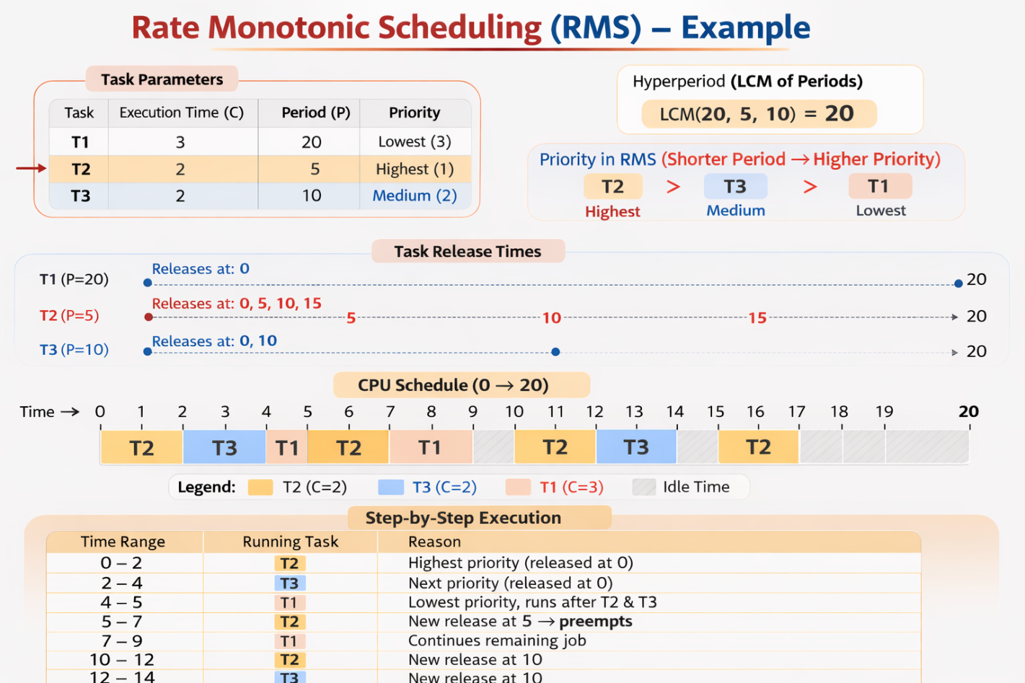

Least Laxity First (LLF) Scheduling
Least Laxity First (LLF), also called Least Slack Time First, is a dynamic priority scheduling algorithm used in real-time operating systems. It schedules tasks based on their laxity (slack time), which represents how much time a task can be delayed without missing its deadline.
In LLF scheduling, the task with the smallest laxity value is given the highest priority and is executed first. If the laxity of another task becomes smaller during execution, the scheduler immediately switches to that task.

Principle
The main principle of LLF scheduling is:
The task with the least laxity (minimum slack time) is executed first.
This ensures that the task closest to missing its deadline receives the highest priority.

Definition of Laxity
Laxity (or slack time) is defined as the difference between the deadline and the remaining execution time considering the current time.
Laxity is calculated using the following formula:
Laxity=Deadline−Current Time−Remaining Execution Time
Where:
- Deadline (D) = Time by which the task must complete
- Current Time (t) = Current system time
- Remaining Execution Time (C) = CPU time still required to finish the task
If the laxity becomes zero, the task must start execution immediately to meet its deadline.

Characteristics of LLF
Least Laxity First scheduling has the following characteristics:
- Dynamic Priority Scheduling
Task priorities change continuously depending on their laxity values.
- Preemptive Scheduling
A running task can be interrupted if another task obtains a smaller laxity.
- Deadline-Oriented Scheduling
LLF ensures tasks closer to missing deadlines are executed first.
- Real-Time Scheduling Technique
LLF is mainly used in hard real-time systems where missing deadlines is unacceptable.
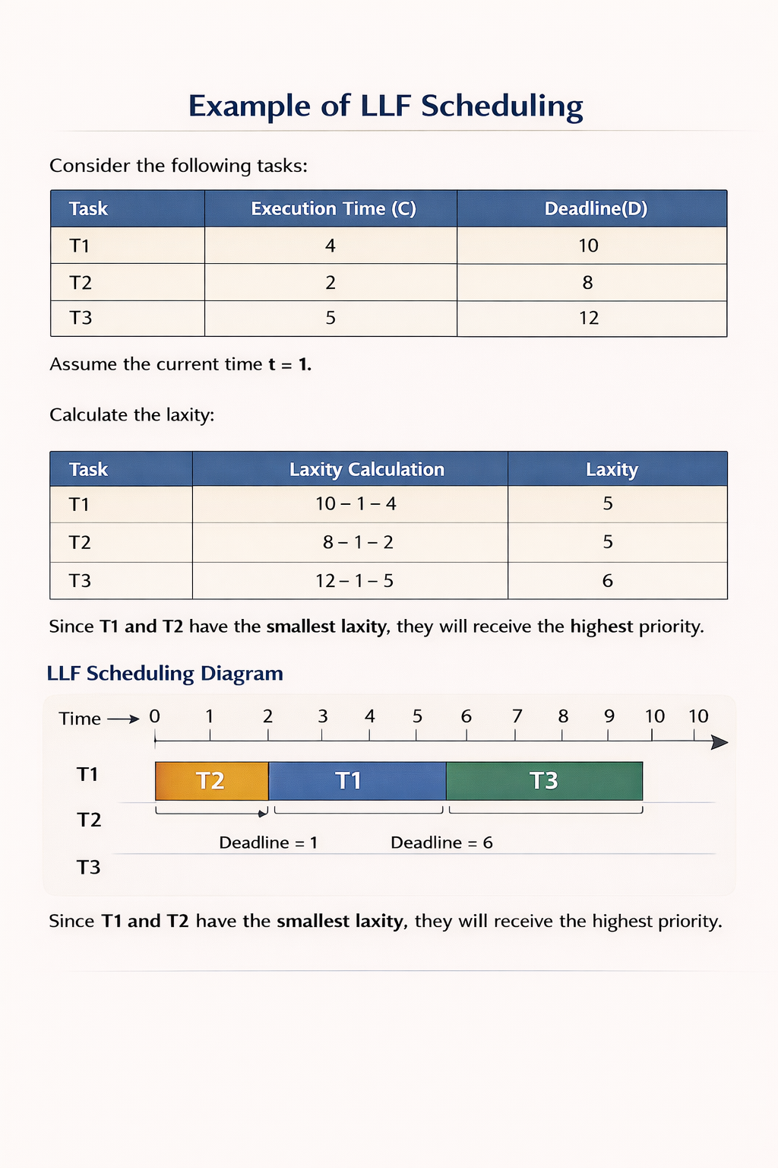Behavior of LLF Scheduling
During system execution:
- Laxity values are continuously updated.
- The scheduler always selects the task with the smallest slack time.
- Frequent recalculation of laxity may cause many context switches.

Advantages of LLF
Least Laxity First scheduling provides several advantages:
• Considers both deadline and remaining execution time
• Provides better decision making for urgent tasks
• Suitable for hard real-time applications
• More flexible than fixed-priority scheduling algorithms

Disadvantages of LLF
Despite its advantages, LLF has some limitations:
• Requires continuous calculation of laxity values
• Causes frequent context switching
• High scheduling overhead
• More complex to implement in practical systems

Applications of LLF
LLF scheduling is used in systems where precise timing control is critical, such as:
- Real-time control systems
- Robotics and automation
- Industrial monitoring systems
- Aerospace and avionics systems
- Medical monitoring equipment

Embedded OS Features: TinyOS and FreeRTOS
Embedded operating systems are specialized operating systems designed to run on embedded systems with limited memory, processing power, and energy consumption. These systems are commonly used in IoT devices, sensor networks, robotics, automotive systems, and industrial controllers.
Two widely used embedded operating systems are TinyOS and FreeRTOS. Both are lightweight operating systems designed to support real-time operations in resource-constrained devices.

1. TinyOS
TinyOS is an open-source embedded operating system designed primarily for wireless sensor networks (WSN). It was developed at the University of California, Berkeley.
TinyOS is designed to operate on very small devices with limited memory and energy resources, such as sensor nodes used in environmental monitoring and IoT systems.

Features of TinyOS

1. Component-Based Architecture
TinyOS uses a modular component-based architecture, where applications are built by connecting small reusable components.
This allows developers to create highly efficient and flexible embedded applications.

2. Event-Driven Execution Model
TinyOS follows an event-driven programming model rather than multithreading.
Tasks are executed when events occur, such as:
- Sensor data arrival
- Timer expiration
- Communication request
This reduces CPU overhead and improves energy efficiency.

3. Low Memory Footprint
TinyOS is designed to run on devices with very limited RAM and storage.
Typical sensor nodes may only have:
- 4 KB – 10 KB RAM
- Small flash memory
TinyOS efficiently manages memory to operate in such environments.

4. Energy Efficiency
TinyOS is optimized for low power consumption, which is critical for battery-powered devices.
It achieves this by:
- Minimizing CPU usage
- Efficient task scheduling
- Supporting sleep modes

5. nesC Programming Language
Applications in TinyOS are written using nesC (Network Embedded Systems C).
nesC is a programming language designed specifically for component-based embedded programming.

6. Wireless Communication Support
TinyOS provides built-in support for:
- Wireless communication protocols
- Sensor network routing
- Data collection systems

Applications of TinyOS
TinyOS is widely used in:
- Wireless sensor networks
- Environmental monitoring systems
- Smart agriculture
- Structural health monitoring
- Internet of Things (IoT)

2. FreeRTOS
FreeRTOS is a popular open-source real-time operating system kernel designed for embedded devices. It is widely used in microcontrollers and small embedded systems.
FreeRTOS supports multitasking and real-time scheduling, making it suitable for applications requiring deterministic timing.

Features of FreeRTOS

1. Real-Time Multitasking
FreeRTOS supports preemptive multitasking, allowing multiple tasks to run concurrently.
The scheduler decides which task should run based on priority levels.

2. Small Memory Footprint
FreeRTOS is extremely lightweight and can run on devices with:
- Very small RAM
- Low processing power
Typical kernel size is only a few kilobytes.

3. Priority-Based Scheduling
FreeRTOS uses priority-based task scheduling, where higher-priority tasks are executed before lower-priority tasks.
Scheduling methods include:
- Preemptive scheduling
- Cooperative scheduling

4. Inter-Task Communication
FreeRTOS provides mechanisms for communication between tasks, such as:
- Queues
- Semaphores
- Mutexes
- Event groups
These mechanisms allow tasks to synchronize and share data safely.

5. Deterministic Behavior
FreeRTOS provides predictable response times, which is essential for real-time systems.
This ensures that time-critical tasks meet their deadlines.

6. Portability
FreeRTOS supports a large number of microcontroller architectures, including:
- ARM Cortex-M
- AVR
- PIC
- RISC-V
- MSP430

7. Modular Design
FreeRTOS allows developers to include only the required components, reducing memory usage.

Applications of FreeRTOS
FreeRTOS is widely used in:
- IoT devices
- Automotive electronics
- Industrial automation
- Consumer electronics
- Robotics systems
- Medical devices
Feature | TinyOS | FreeRTOS
Architecture | Component-based | Kernel-based
Programming Model | Event-driven | Multithreading
Language | nesC | C
Scheduling | Event-driven tasks | Priority-based scheduler
Target Systems | Sensor networks | General embedded systems
Memory Usage | Extremely low | Low
Real-Time Support | Limited | Strong real-time support

Energy-Efficient Operating System Design
Energy-efficient operating system design focuses on minimizing power consumption while maintaining system performance. This type of design is particularly important in embedded systems, mobile devices, IoT devices, and wireless sensor networks, where devices often operate on limited battery power.
An energy-efficient OS manages hardware resources, scheduling, and system operations in such a way that energy usage is reduced without compromising system functionality.

1. Need for Energy-Efficient OS Design
Modern embedded and mobile systems must operate for long periods on limited power sources such as batteries. Therefore, the operating system must implement techniques that reduce energy consumption.
Reasons for energy-efficient OS design include:
- Extending battery life of devices
- Reducing heat generation
- Improving system reliability
- Supporting portable and wearable devices
- Enabling long-term operation of sensor networks

2. Key Principles of Energy-Efficient OS Design
Energy-efficient operating systems follow several important principles.

1. Efficient Resource Management
The OS must manage system resources such as CPU, memory, and I/O devices efficiently to reduce unnecessary energy usage.
Example:
- Turning off unused hardware components.

2. Dynamic Power Management (DPM)
Dynamic Power Management allows the operating system to switch hardware devices between different power states.
Common power states include:
State | Description
Active | Device fully operational
Idle | Device waiting for work
Sleep | Low power mode
Off | Device completely powered down
When a device is not in use, the OS places it into a low-power state.

3. Dynamic Voltage and Frequency Scaling (DVFS)
DVFS reduces power consumption by adjusting CPU voltage and frequency based on workload.
- Low workload → Lower frequency and voltage
- High workload → Higher frequency and voltage
This significantly reduces power usage.

4. Energy-Aware Scheduling
In energy-efficient OS design, the scheduler selects tasks in a way that minimizes energy consumption.
Examples include:
- Scheduling tasks together to allow longer sleep periods
- Reducing frequent context switching
- Using low-power cores when possible

5. Sleep Mode Management
The OS places the processor and other components into sleep or idle modes when no tasks are running.
This is commonly used in:
- IoT devices
- Sensor nodes
- Mobile devices

6. Efficient Memory Management
Memory operations consume energy. The OS reduces energy consumption by:
- Minimizing memory access
- Using memory caching techniques
- Optimizing memory allocation

3. Techniques Used in Energy-Efficient OS
Several techniques are used to achieve energy-efficient operating systems.

1. Power-Aware Scheduling
Tasks are scheduled in a way that reduces CPU power consumption.

2. Device Power Management
The OS turns off or reduces power for unused devices such as:
- Sensors
- Network modules
- Storage devices

3. Energy-Aware Networking
Communication consumes significant power in wireless devices. The OS reduces energy usage by:
- Minimizing radio transmission
- Aggregating data packets
- Using low-power communication protocols

4. Duty Cycling
Duty cycling allows devices to alternate between active and sleep states.
Example:
Sensor nodes wake up periodically to collect data and then return to sleep mode.

Energy-Efficient Operating System Design
Energy-efficient operating system design focuses on minimizing power consumption while maintaining system performance. This type of design is particularly important in embedded systems, mobile devices, IoT devices, and wireless sensor networks, where devices often operate on limited battery power.
An energy-efficient OS manages hardware resources, scheduling, and system operations in such a way that energy usage is reduced without compromising system functionality.

1. Need for Energy-Efficient OS Design
Modern embedded and mobile systems must operate for long periods on limited power sources such as batteries. Therefore, the operating system must implement techniques that reduce energy consumption.
Reasons for energy-efficient OS design include:
- Extending battery life of devices
- Reducing heat generation
- Improving system reliability
- Supporting portable and wearable devices
- Enabling long-term operation of sensor networks

2. Key Principles of Energy-Efficient OS Design
Energy-efficient operating systems follow several important principles.

1. Efficient Resource Management
The OS must manage system resources such as CPU, memory, and I/O devices efficiently to reduce unnecessary energy usage.
Example:
- Turning off unused hardware components.

2. Dynamic Power Management (DPM)
Dynamic Power Management allows the operating system to switch hardware devices between different power states.
Common power states include:
State | Description
Active | Device fully operational
Idle | Device waiting for work
Sleep | Low power mode
Off | Device completely powered down
When a device is not in use, the OS places it into a low-power state.

3. Dynamic Voltage and Frequency Scaling (DVFS)
DVFS reduces power consumption by adjusting CPU voltage and frequency based on workload.
- Low workload → Lower frequency and voltage
- High workload → Higher frequency and voltage
This significantly reduces power usage.

4. Energy-Aware Scheduling
In energy-efficient OS design, the scheduler selects tasks in a way that minimizes energy consumption.
Examples include:
- Scheduling tasks together to allow longer sleep periods
- Reducing frequent context switching
- Using low-power cores when possible

5. Sleep Mode Management
The OS places the processor and other components into sleep or idle modes when no tasks are running.
This is commonly used in:
- IoT devices
- Sensor nodes
- Mobile devices

6. Efficient Memory Management
Memory operations consume energy. The OS reduces energy consumption by:
- Minimizing memory access
- Using memory caching techniques
- Optimizing memory allocation

3. Techniques Used in Energy-Efficient OS
Several techniques are used to achieve energy-efficient operating systems.

1. Power-Aware Scheduling
Tasks are scheduled in a way that reduces CPU power consumption.

2. Device Power Management
The OS turns off or reduces power for unused devices such as:
- Sensors
- Network modules
- Storage devices

3. Energy-Aware Networking
Communication consumes significant power in wireless devices. The OS reduces energy usage by:
- Minimizing radio transmission
- Aggregating data packets
- Using low-power communication protocols

4. Duty Cycling
Duty cycling allows devices to alternate between active and sleep states.
Example:
Sensor nodes wake up periodically to collect data and then return to sleep mode.
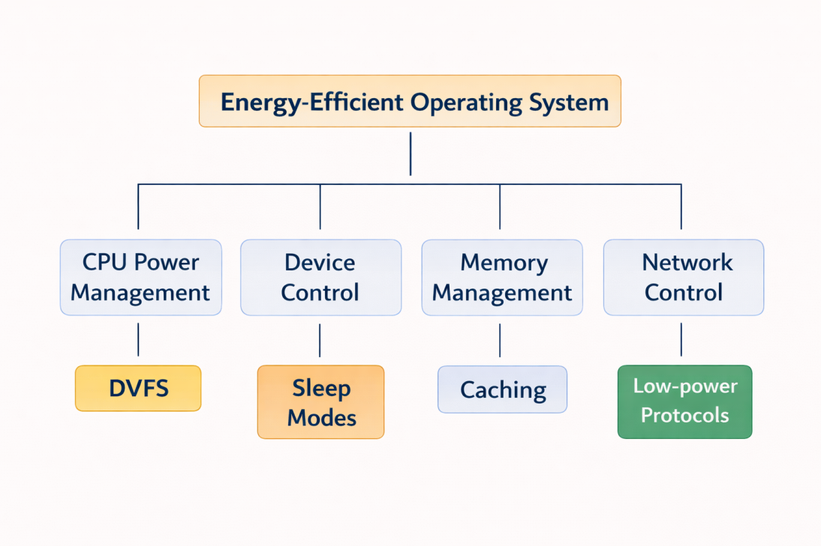

5. Advantages of Energy-Efficient OS Design
Energy-efficient operating systems provide several benefits:
- Longer battery life
- Reduced heat generation
- Improved reliability
- Better performance per watt
- Suitable for mobile and embedded systems

6. Applications of Energy-Efficient OS
Energy-efficient operating systems are used in many modern technologies, including:
- Wireless sensor networks
- Internet of Things (IoT) devices
- Smartphones and tablets
- Wearable devices
- Embedded medical systems
- Smart home systems

